CHAPTER 1
COMPANY
  - Company Profile
EduPhoenix Solutions is a dynamic and innovative company dedicated to providing cutting-edge solutions in the field of education technology. Established with a vision to revolutionize learning experiences, EduPhoenix Solutions offers a comprehensive range of products and services tailored to meet the evolving needs of educational institutions, students, and educators.
At EduPhoenix Solutions, we leverage the latest advancements in technology to develop intuitive and interactive educational platforms, tools, and resources. Our team of experts is committed to designing and delivering solutions that enhance teaching effectiveness, engage learners, and foster academic success.
From e-learning platforms and virtual classrooms to customized educational software and mobile applications, EduPhoenix Solutions offers a diverse portfolio of products aimed at transforming traditional learning paradigms. We prioritize user-centric design, ensuring that our solutions are user-friendly, accessible, and adaptable to diverse learning environments.

Figure 1.1 Company Logo
In addition to our innovative products, EduPhoenix Solutions provides consultancy services, training programs, and ongoing support to help educational institutions maximize the impact of technology on teaching and learning outcomes. Our collaborative approach enables us to work closely with clients to understand their unique challenges and goals, delivering tailored solutions that drive positive change and innovation.
EduPhoenix Solutions stands at the forefront of educational technology, driven by a passion for innovation and a commitment to excellence. With a deep understanding of the challenges facing modern educational institutions, we offer a comprehensive suite of solutions designed to elevate teaching and learning experiences to new heights.
Our team of experts combines extensive experience in both education and technology to develop cutting-edge platforms and tools that empower educators and engage learners. By harnessing the latest advancements in artificial intelligence, data analytics, and user-centric design, we create intuitive and immersive learning environments that foster creativity, critical thinking, and collaboration.
Beyond our innovative products, EduPhoenix Solutions provides strategic consultancy services and professional development programs to support educational institutions in leveraging technology effectively. From needs assessment and solution design to implementation and ongoing support, we partner with our clients every step of the way to ensure the success of their digital initiatives.
With a strong focus on user experience, accessibility, and scalability, our solutions are tailored to meet the unique needs of diverse educational settings, from K-12 schools to higher education institutions and corporate training programs. By delivering customizable, adaptable, and future-ready solutions, we empower educators to deliver high-quality instruction and empower learners to achieve their full potential in an increasingly digital world.
Driven by a shared vision of transforming education through technology, EduPhoenix Solutions is dedicated to pushing the boundaries of innovation and driving positive change in the education landscape. As we continue to evolve and expand our offerings, we remain steadfast in our commitment to delivering impactful solutions that inspire lifelong learning and shape the future of education.
With a commitment to excellence, integrity, and continuous improvement, EduPhoenix Solutions is dedicated to empowering educators, inspiring learners, and shaping the future of education through technology. We are proud to partner with educational institutions worldwide, helping them unlock the full potential of digital learning in the 21st century.

1.2 Company Overview
EduPhoenix Solutions is a dynamic and forward-thinking company that specializes in providing innovative educational technology solutions to institutions worldwide. Established with a vision to revolutionize the way education is delivered and experienced, EduPhoenix Solutions has quickly emerged as a leader in the field, offering a wide range of cutting-edge products and services tailored to meet the diverse needs of educators and learners alike.
At EduPhoenix Solutions, we believe that technology has the power to transform education by making learning more accessible, engaging, and effective. With this belief at the core of our mission, we strive to develop solutions that empower educators to deliver high-quality instruction and enable learners to reach their full potential.
Our comprehensive suite of products and services encompasses everything from learning management systems and virtual classrooms to interactive content authoring tools and professional development programs. Whether it's providing educators with the tools they need to create immersive learning experiences or offering learners access to dynamic and interactive learning environments, EduPhoenix Solutions is committed to driving positive change in education through technology.
One of the key strengths of EduPhoenix Solutions lies in our team of experts, who bring a wealth of experience and expertise from diverse fields such as education, technology, instructional design, and user experience. By combining our knowledge and skills, we are able to develop innovative solutions that address the evolving needs of the education sector and deliver measurable results.
In addition to our product offerings, EduPhoenix Solutions also provides consultancy services to educational institutions seeking to leverage technology effectively. From needs assessment and solution design to implementation and ongoing support, our team works closely with clients to develop customized strategies and solutions that align with their unique goals and objectives.
As a company, we are deeply committed to excellence, integrity, and customer satisfaction. We take pride in our ability to deliver high-quality products and services that meet the highest standards of quality and reliability. With a customer-centric approach and a focus on continuous improvement, we strive to exceed our clients' expectations and build long-lasting partnerships based on trust and mutual respect.

  - Company Departments
EduPhoenix Solutions operates across several departments, each contributing to the overall mission of delivering innovative educational solutions and services. These departments include:

Human Resources (HR) Department:
Recruitment and Talent Acquisition: This involves identifying staffing needs, sourcing candidates through job postings and recruitment agencies, conducting interviews, and selecting the best-fit candidates.
Employee Onboarding and Orientation: HR ensures that new hires receive necessary training, complete required paperwork, understand company policies, and integrate smoothly into their roles and the organization.
Performance Management: HR oversees performance evaluations, goal setting, feedback mechanisms, and recognition programs to foster employee growth, development, and engagement.
Employee Relations: This department handles employee grievances, conflicts, disciplinary actions, and ensures compliance with employment laws and regulations.
Training and Development: HR designs and implements training programs, workshops, and seminars to enhance employee skills, competencies, and professional development opportunities.
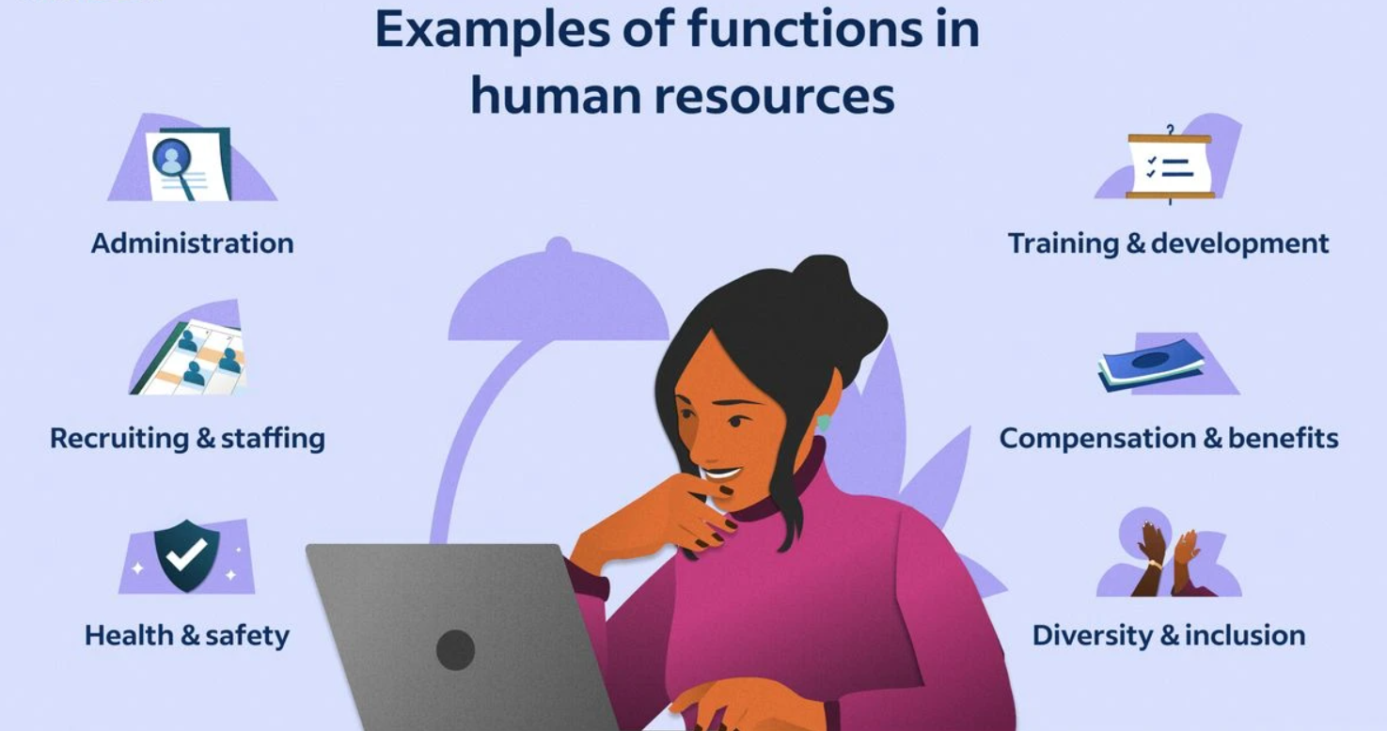
Figure 1.3.1 Functions of Human Resources (HR)

Information Technology (IT) and Technical Support Department:
Infrastructure Management: This includes managing servers, networks, hardware, and software systems to ensure seamless operation, security, and scalability.
Systems Administration: IT administrators monitor system performance, troubleshoot technical issues, install updates, and ensure data backups and recovery protocols are in place.
Cybersecurity: This team protects the organization from cyber threats by implementing firewalls, antivirus software, intrusion detection systems (IDS), and conducting regular security audits and assessments.
Software Development: IT professionals develop and maintain custom software applications, websites, and digital platforms to support internal operations and customer-facing solutions.
Technical Support: The IT helpdesk provides technical assistance, resolves user issues, and offers guidance on software usage, hardware configuration, and network connectivity.
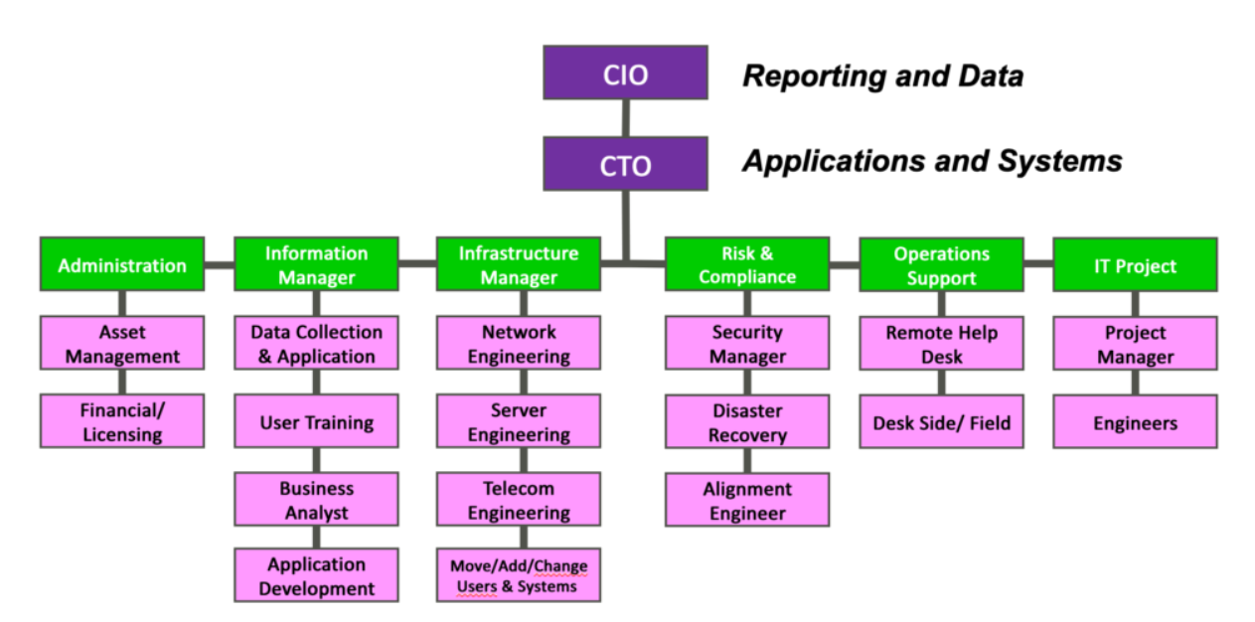
Figure 1.3.2 Information Technology (IT) Department Structure

Research and Development (R&D) Department:
Market Research and Analysis: R&D conducts market research to identify industry trends, customer preferences, and competitive landscapes to inform product development strategies.
Product Innovation: This team conceptualizes and prototypes new products, features, and services, leveraging emerging technologies and customer feedback to drive innovation.
Prototype Development: R&D builds and tests prototypes to validate concepts, assess feasibility, and gather user feedback before full-scale development and commercialization.
Intellectual Property Management: This involves securing patents, trademarks, and copyrights to protect the organization's innovations, inventions, and creative works from infringement.
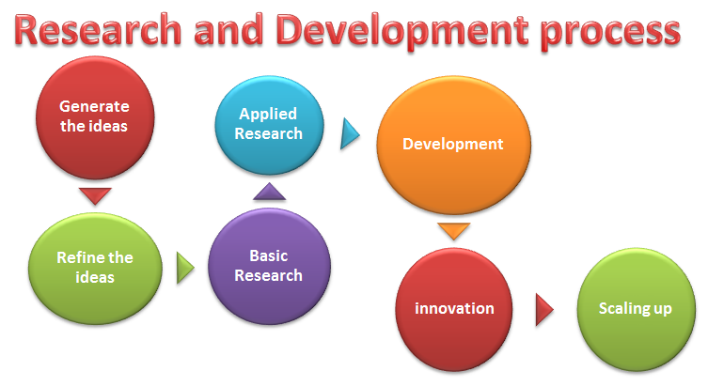
Figure1.3.3 Research & Development Process

Sales and Marketing Department:Market Segmentation and Targeting: Sales and marketing professionals identify and segment target markets based on demographics, behaviors, and preferences to tailor marketing messages and campaigns.
Lead Generation and Nurturing: This team generates leads through advertising, content marketing, and networking efforts, then nurtures those leads through email campaigns, follow-up calls, and personalized communication.
Brand Management: Sales and marketing professionals develop brand identity, messaging, and positioning strategies to differentiate EduPhoenix Solutions from competitors and build brand loyalty.
Digital Marketing: This involves leveraging digital channels such as websites, social media platforms, search engine optimization (SEO), and pay-per-click (PPC) advertising to reach and engage target audiences.
Sales Enablement: Sales enablement teams provide sales reps with the tools, resources, and training needed to effectively communicate product features, benefits, and value propositions to prospects and customers.

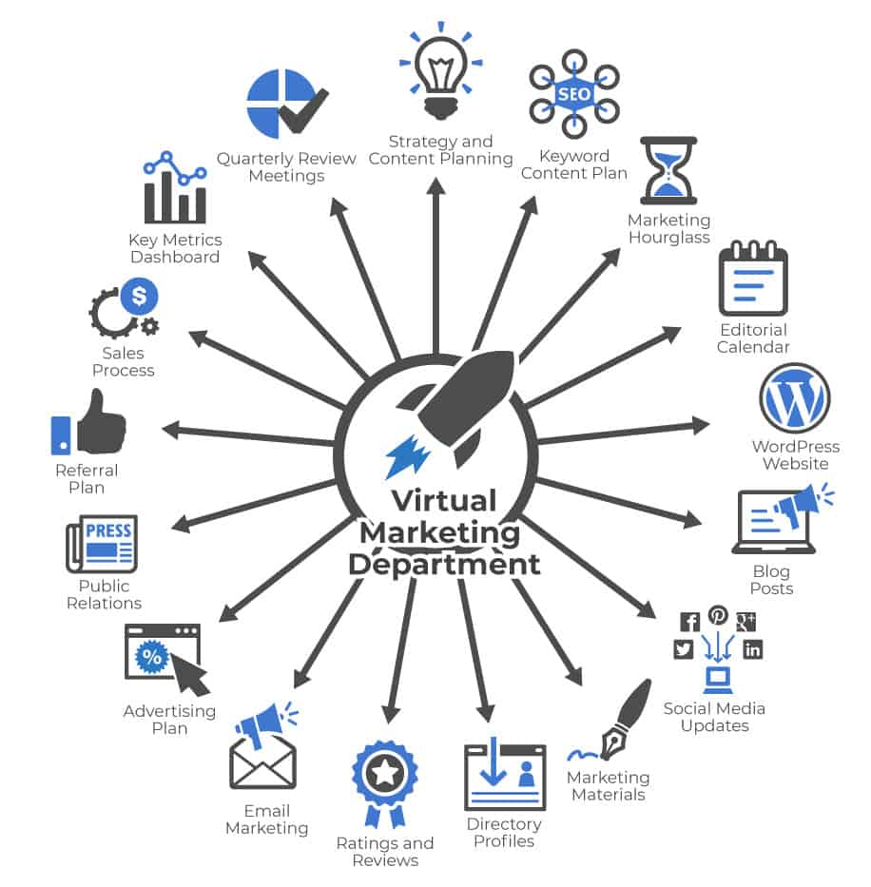

Figure 1.3.4(a) Virtual Marketing  Department | Figure 1.3.4(b) Marketing  Department

Customer Success Department:
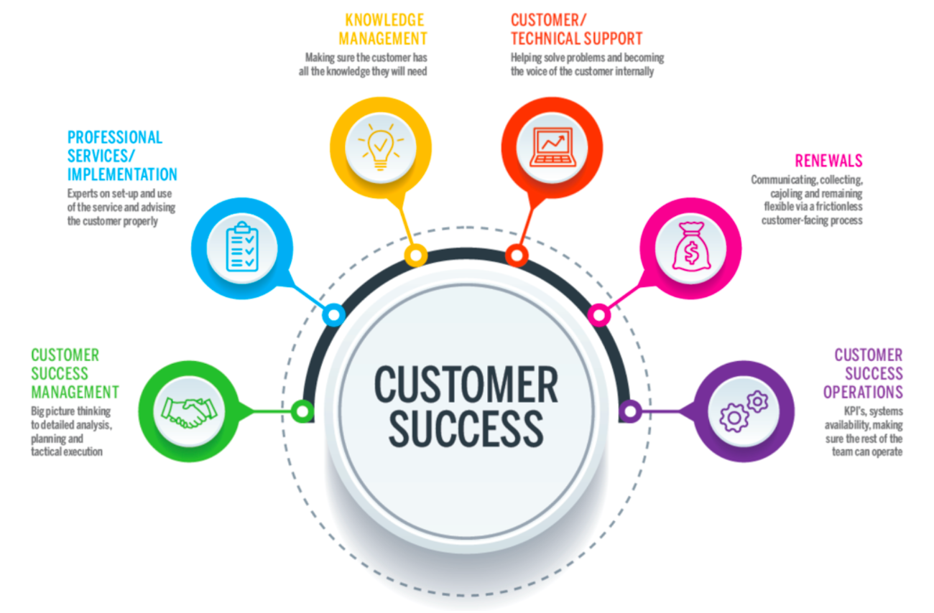
Customer Onboarding: This involves guiding new customers through the implementation process, providing training, support, and resources to ensure successful adoption and utilization of EduPhoenix Solutions.
Figure 1.3.5 Customer Success
Customer Relationship Management: Customer success managers build and nurture relationships with clients, acting as their advocate within the organization and ensuring their needs and expectations are met.
Account Management: This team is responsible for managing customer accounts, identifying upsell and cross-sell opportunities, and fostering long-term relationships to drive retention and expansion.
Customer Support: The customer support team provides responsive assistance, troubleshooting, and issue resolution to address customer inquiries, technical challenges, and service disruptions effectively.

Finance and Accounting Department:
Financial Planning and Analysis: This department is responsible for budgeting, forecasting, financial modeling, and providing insights to support strategic decision-making.
Accounts Payable and Receivable: Finance professionals manage payments to vendors, invoicing customers, and tracking receivables to ensure timely cash flow management.
Financial Reporting and Compliance: This team prepares financial statements, regulatory filings, and ensures compliance with accounting standards, tax laws, and industry regulations.
Treasury Management: Finance professionals oversee cash management, investment strategies, and risk mitigation to optimize liquidity and financial stability.

Figure 1.3.6 Finance & Accounting

Legal and Compliance Department:
Contract Management: Legal professionals draft, review, and negotiate contracts with clients, partners, and vendors to protect EduPhoenix Solutions' interests and mitigate legal risks.
Regulatory Compliance: This team ensures compliance with laws, regulations, and industry standards related to data privacy, security, intellectual property, and consumer protection.
Intellectual Property (IP) Management: Legal experts manage EduPhoenix Solutions' intellectual property portfolio, including patents, trademarks, copyrights, and trade secrets.
Risk Management: The legal and compliance department identifies, assesses, and manages legal and regulatory risks to minimize exposure and protect the organization from liabilities.
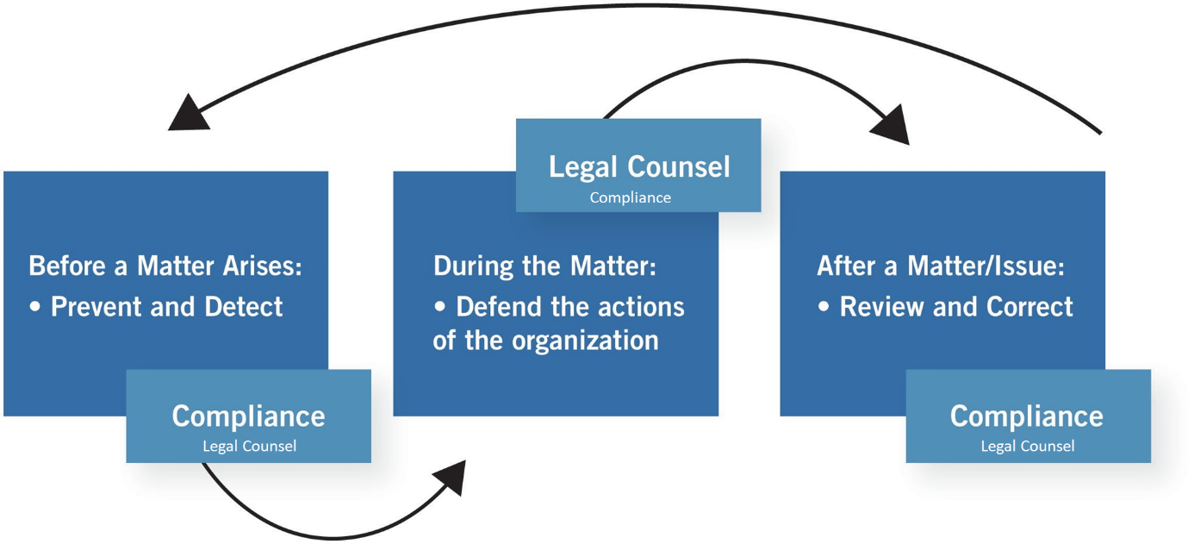
Figure 1.3.7 Legal & Compliance Procedure

Operations and Logistics Department:
Supply Chain Management: Operations professionals oversee procurement, inventory management, and logistics to ensure timely delivery of goods and services while optimizing costs and efficiency.
Facilities Management: This team maintains and manages office facilities, equipment, and infrastructure to create a safe, productive, and comfortable work environment.
Quality Assurance and Control: Operations experts develop and implement quality standards, processes, and metrics to ensure products and services meet or exceed customer expectations.

Figure 1.3.8(a) Operations  Management | Figure 1.3.8(b) Logistics

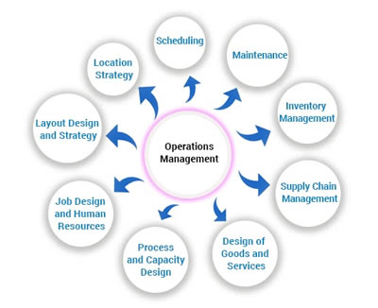
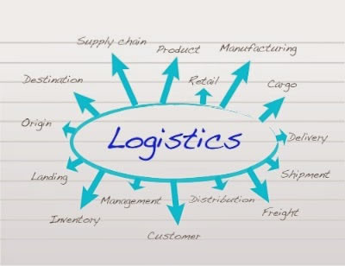
Project Management: Operations professionals coordinate cross-functional projects, allocate resources, and track progress to ensure timely completion and successful outcomes.

Customer Experience Department:
User Experience (UX) Design: This team focuses on designing intuitive, user-friendly interfaces and interactions for digital products and platforms to enhance customer satisfaction and engagement.
Customer Insights and Analytics: CX professionals analyze customer feedback, behavior data, and performance metrics to gain actionable insights and drive continuous improvement initiatives.
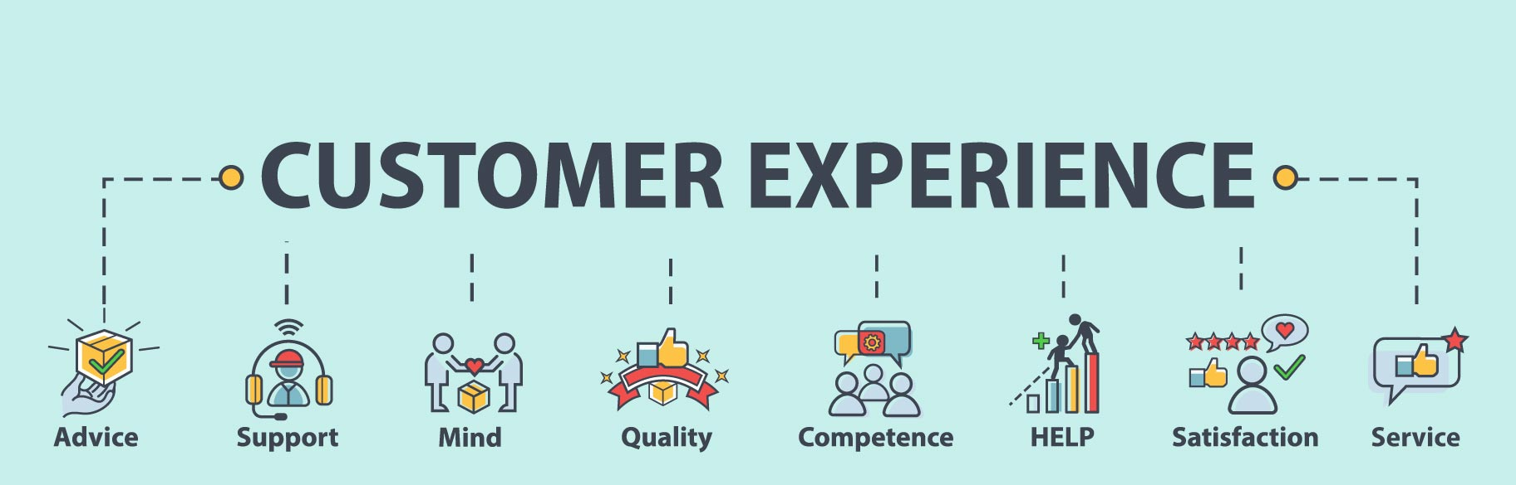
Customer Advocacy: This department represents the voice of the customer within the organization, advocating for their needs, preferences, and concerns to inform product development and decision-making.
Figure 1.3.9 Customer Experience
Customer Satisfaction and Retention: CX professionals develop strategies and programs to measure and improve customer satisfaction, loyalty, and retention rates through proactive engagement and personalized experiences.

Business Development and Partnerships Department:
Strategic Partnerships: Business development professionals identify and cultivate strategic alliances, joint ventures, and partnerships with other companies to expand market reach, access new resources, and drive growth.

Market Expansion: This team explores new markets, geographies, and customer segments to identify growth opportunities and develop market entry strategies to capitalize on emerging trends.
Channel Development: Business development experts establish and manage distribution channels, reseller networks, and affiliate programs to extend EduPhoenix Solutions' reach and increase sales volume.
Competitive Intelligence: This department monitors competitors' activities, market trends, and industry developments to identify threats and opportunities, inform strategic decision-making, and maintain a competitive edge.

Figure 1.3.10 Business Development
Quality Assurance and Testing Department:
Quality Assurance (QA) Testing is a critical function that ensures products and services meet specified quality standards before they are released to customers. This involves systematically testing various aspects of software, hardware, or other deliverables to identify defects or areas for improvement.
QA testers develop comprehensive test plans, scenarios, and scripts based on project requirements and specifications. These documents outline the testing approach, test cases, and expected outcomes for each test scenario.
Different types of testing are performed throughout the development lifecycle, including functional testing, which verifies that the system meets specified functional requirements, and regression testing, which ensures that new changes do not adversely impact existing functionality.

Figure 1.3.11(a) Quality Assurance | Figure 1.3.11(b) Testing

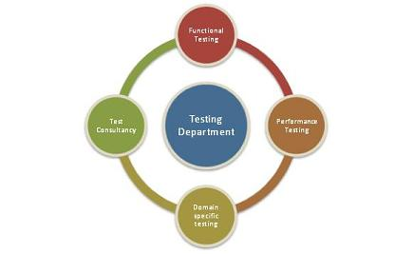
User acceptance testing (UAT) is conducted to validate the product against user expectations and requirements. This involves engaging end-users to evaluate the product's usability, accessibility, and overall user experience.
QA testers use a variety of testing techniques and tools to identify defects and bugs in the system. This may include manual testing, automated testing, performance testing, security testing, and usability testing, among others.
Throughout the testing process, QA testers document their findings, including any defects or issues discovered during testing. They work closely with development teams to prioritize and address these issues, ensuring that high-priority defects are resolved promptly.
Continuous improvement is a key aspect of QA testing, with testers regularly reviewing and refining testing processes and methodologies to enhance efficiency and effectiveness. This may involve implementing new tools, adopting best practices, and incorporating feedback from stakeholders to drive quality improvements.
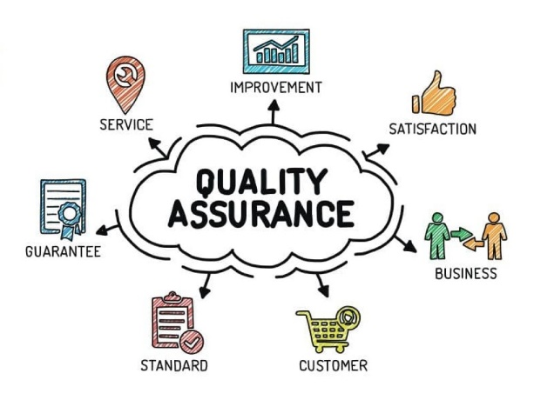

Grievance and Conflict Resolution Department:
The Grievance and Conflict Resolution department is responsible for managing disputes, grievances, and conflicts within the organization. This department serves as a neutral mediator, helping parties resolve issues in a fair and equitable manner.
One of the primary functions is to provide employees and stakeholders with a platform to express their concerns and grievances. This could involve setting up confidential reporting mechanisms, such as hotlines or online portals, where individuals can raise issues anonymously.
The department investigates complaints and conflicts thoroughly, gathering relevant information and evidence to understand the root causes of the problem. Depending on the nature of the issue, this may involve conducting interviews, reviewing documentation, or engaging in alternative dispute resolution methods like mediation or arbitration.
Once the investigation is complete, the department works towards finding a resolution that addresses the concerns of all parties involved. This could involve implementing corrective actions, revising policies or procedures, or providing training and support to prevent similar issues from arising in the future.
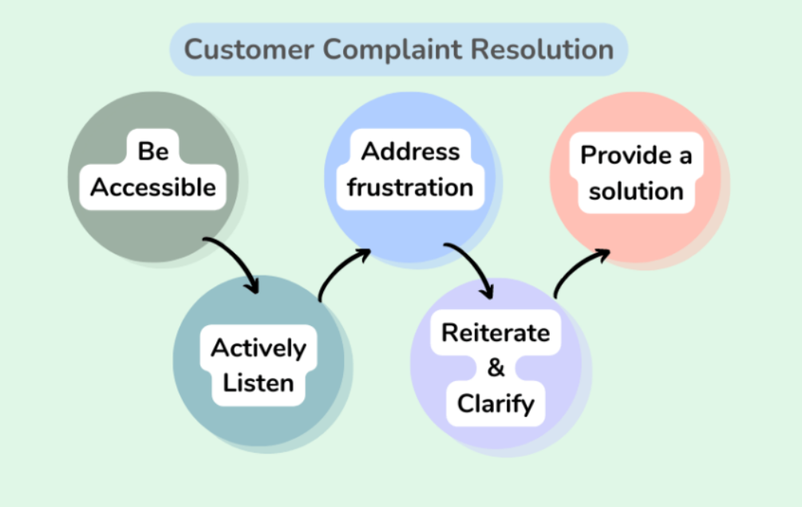
Figure 1.3.12 Customer Complaint Resolution
Additionally, the Grievance and Conflict Resolution department may play a role in promoting a positive organizational culture by fostering open communication, trust, and collaboration among employees. This includes promoting conflict resolution skills and providing resources for managing interpersonal conflicts effectively.

These departments play integral roles in ensuring the success and growth of EduPhoenix Solutions by effectively managing resources, delivering high-quality products and services, and delivers comprehensive educational solutions that empower learners, educators, and institutions to succeed in a rapidly evolving digital landscape.

  - Company Products/Applications
EduPhoenix Solutions prides itself on offering a diverse array of cutting-edge educational technology products and applications designed to cater to the evolving needs of educators and learners alike. Our commitment to innovation and excellence drives us to develop solutions that enhance teaching effectiveness, promote student engagement, and ultimately elevate the learning experience. Here's a detailed overview of our key products and applications:
- Learning Management System (LMS):
Our Learning Management System (LMS) serves as the cornerstone of our educational technology suite. This robust platform provides educators with the tools they need to create, deliver, and manage online courses and educational content seamlessly. With intuitive course creation features, comprehensive content management capabilities, and robust assessment tools, our LMS empowers educators to design dynamic and interactive learning experiences. Moreover, real-time analytics and reporting functionalities enable educators to monitor student progress and performance effectively.

- Virtual Classroom:
In today's digital age, our Virtual Classroom platform offers educators a versatile and immersive online learning environment. Equipped with video conferencing, screen sharing, interactive whiteboards, and chat functionality, this platform facilitates real-time collaboration and interaction between educators and students. Whether conducting live classes, webinars, or virtual workshops, educators can engage learners effectively and foster meaningful learning experiences. Seamless integration with our LMS ensures streamlined course delivery and administration.

- Interactive Content Authoring Tools:
Our suite of interactive content authoring tools empowers educators to create engaging and multimedia-rich learning materials with ease. Featuring user-friendly interfaces, customizable templates, and multimedia integration capabilities, these authoring tools enable educators to develop interactive presentations, quizzes, simulations, and games effortlessly. With built-in assessment and tracking features, educators can assess student comprehension and progress in real time, ensuring that learning objectives are met effectively.

- Professional Development Programs:
Recognizing the importance of continuous professional development, we offer a wide range of training courses and programs designed to enhance educators' skills and knowledge in educational technology and pedagogy. From digital literacy and blended learning to instructional design and technology integration, our professional development programs cover a diverse array of topics. Whether educators are looking to expand their expertise in specific areas or earn certifications in educational technology, our programs provide valuable opportunities for growth and advancement.

- Consultancy Services:
Our consultancy services cater to educational institutions seeking expert guidance and support in leveraging technology for teaching and learning. Our team of seasoned consultants collaborates closely with clients to assess their unique needs, develop tailored technology solutions, and provide ongoing training and support. From strategic planning and needs analysis to implementation and evaluation, our consultancy services empower institutions to maximize the impact of educational technology and achieve their educational goals effectively.

- IoT Projects:
Internet of Things (IoT) projects involve the integration of physical devices, sensors, and software applications to enable connectivity and data exchange. These projects often focus on leveraging IoT technologies to create smart systems, automate processes, and gather insights from real-world data. Eduphoenix Solutions offers a range of IoT projects aimed at providing hands-on learning experiences to students and professionals.
These projects typically cover areas such as:
Sensor Integration: Students learn to integrate various sensors such as temperature sensors, humidity sensors, motion sensors, and environmental sensors into IoT devices and systems.
Data Acquisition and Processing: Projects involve collecting data from sensors and processing it using microcontrollers or single-board computers like Arduino, Raspberry Pi, or ESP8266/ESP32.
Connectivity and Communication: Students explore different communication protocols such as Wi-Fi, Bluetooth, Zigbee, and LoRa to enable connectivity between IoT devices and networks.
IoT Applications: Projects may focus on developing IoT applications for smart homes, smart cities, industrial automation, healthcare monitoring, environmental monitoring, agriculture, and more.
Cloud Integration: Integration with cloud platforms such as AWS IoT, Google Cloud IoT, or Microsoft Azure IoT enables students to store, analyze, and visualize IoT data, as well as implement cloud-based services like remote monitoring and control.
Security and Privacy: Emphasis is placed on implementing security measures such as encryption, authentication, and access control to protect IoT systems from cyber threats and ensure data privacy.

- AI-ML Projects:
Artificial Intelligence (AI) and Machine Learning (ML) projects involve the development and application of algorithms and models to analyze data, make predictions, and automate tasks without explicit programming instructions. These projects harness the power of AI and ML techniques to solve complex problems, optimize processes, and extract insights from data. Eduphoenix Solutions offers a variety of AI-ML projects aimed at fostering understanding and proficiency in these transformative technologies.
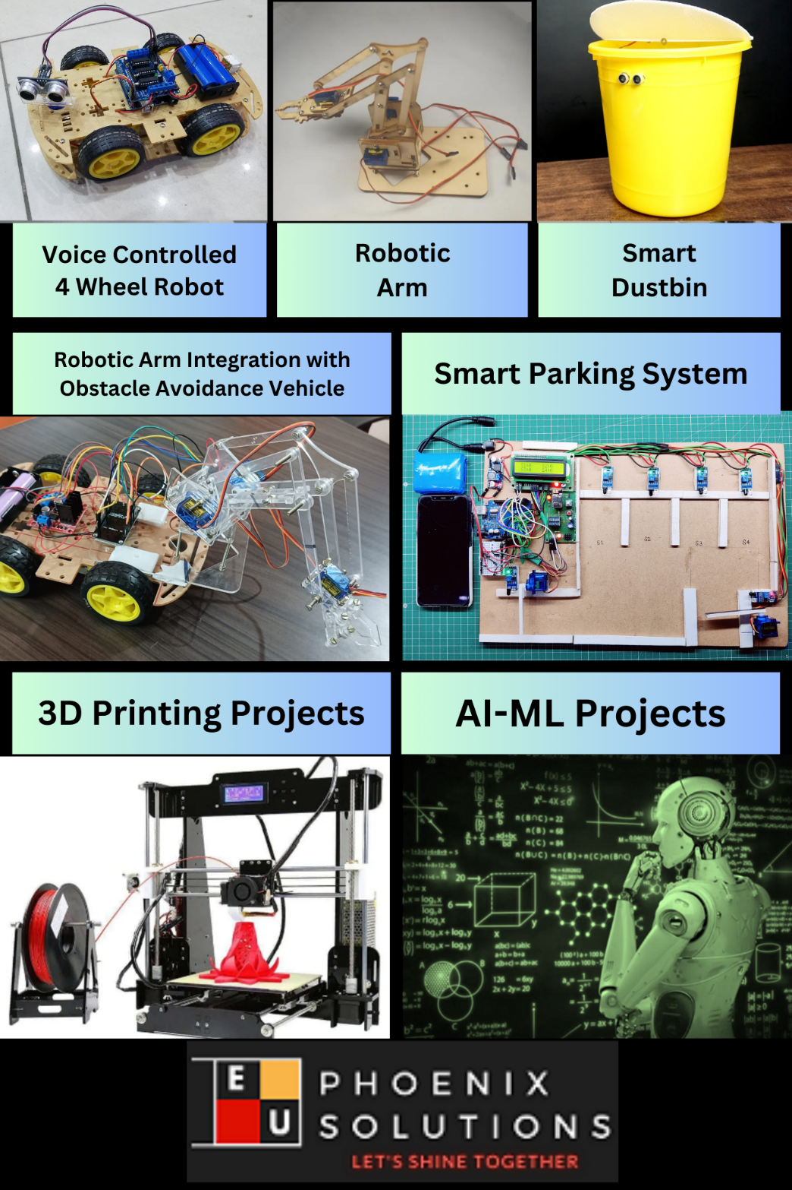

Figure 1.4.1 Company Products

Key components of AI-ML projects include:
Data Collection and Preparation: Projects begin with data collection from various sources such as sensors, databases, or web APIs. Data preprocessing techniques are then applied to clean, transform, and prepare the data for analysis.
Algorithm Selection and Model Development: Students explore different AI and ML algorithms such as regression, classification, clustering, neural networks, and deep learning to build predictive models and solve specific problems.
Model Training and Evaluation: The models are trained using abelled data, and their performance is evaluated using metrics such as accuracy, precision, recall, and F1-score. Hyperparameter tuning and cross-validation techniques are applied to optimize model performance.
Deployment and Integration: Once trained and evaluated, the models are deployed into production environments and integrated with existing systems or applications to deliver real-world value. This may involve deploying models on edge devices, cloud platforms, or IoT devices.

Overall, IoT and AI-ML projects offered by EduPhoenix Solutions provide participants with practical experience, critical thinking skills, and technical expertise in emerging technologies, preparing them for careers in the rapidly evolving fields of IoT and AI-ML.

CHAPTER 2
DOMAIN: MACHINE LEARNING WITH PYTHON

2.1 Introduction
Machine learning, a subset of artificial intelligence, has revolutionized various industries by enabling computers to learn from data and make predictions or decisions without being explicitly programmed. Python, with its rich ecosystem of libraries and frameworks, has become one of the most popular languages for implementing machine learning algorithms and building intelligent systems. In this introduction, we'll delve into the basics of machine learning with Python, its significance, and its applications.
Machine learning algorithms allow computers to learn patterns from data and make predictions or decisions based on that learning. These algorithms are trained on large datasets, which enable them to recognize complex patterns and relationships, leading to valuable insights and predictions. Python, with its simplicity, readability, and extensive libraries such as NumPy, pandas, scikit-learn, TensorFlow, and Keras, provides an ideal environment for implementing machine learning solutions.
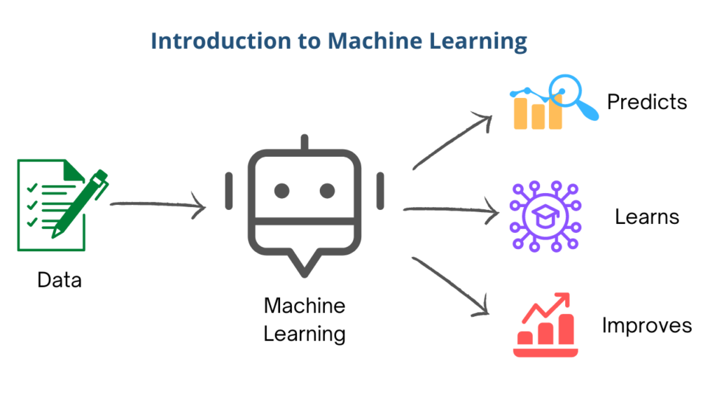
Figure 2.1 Introduction to Machine Learning
The significance of machine learning with Python lies in its ability to automate tasks, make data-driven decisions, and uncover hidden patterns or insights from data. From predicting customer behavior and optimizing business processes to diagnosing diseases and analyzing financial markets, machine learning has found applications across diverse domains. Python's versatility and ease of use make it accessible to both beginners and experts in the field of machine learning.
Moreover, Python's open-source nature fosters a collaborative community of developers, researchers, and practitioners who continuously contribute to its growth and development. This vibrant ecosystem ensures that developers have access to cutting-edge tools, algorithms, and resources for building machine learning models and applications.
In this internship at EduPhoenix Solutions, we'll explore the fundamentals of machine learning with Python, including data preprocessing, model training, evaluation, and deployment. Through hands-on projects and real-world applications, interns will gain practical experience in leveraging Python for solving complex problems and extracting valuable insights from data.

2.2 Overview
Machine learning (ML) with Python is a dynamic field that encompasses the study and application of algorithms and statistical models that enable computer systems to progressively improve their performance on a specific task without being explicitly programmed. Python has emerged as one of the most popular programming languages for machine learning due to its simplicity, versatility, and extensive libraries such as NumPy, Pandas, and Scikit-learn.
In this overview, we'll explore the fundamental concepts of machine learning with Python and its applications in various domains.
- Introduction to Machine Learning: Machine learning involves the development of algorithms that allow computers to learn from data and make predictions or decisions. It can be broadly categorized into supervised learning, unsupervised learning, and reinforcement learning.
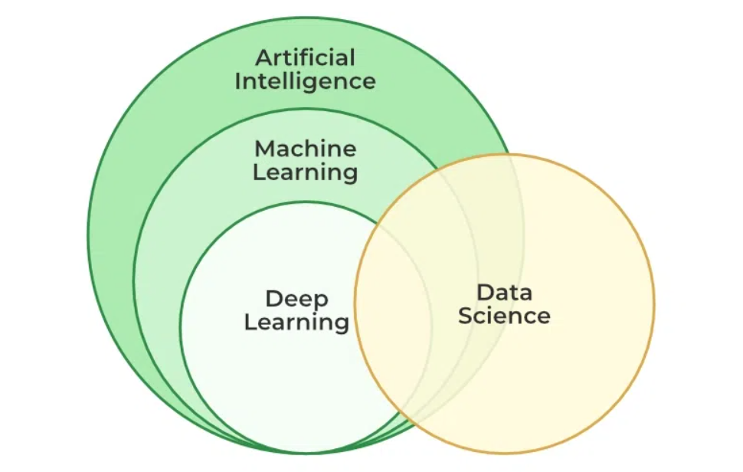
Figure 2.2 Machine Learning Overview
- Python for Machine Learning: Python provides a powerful and flexible platform for implementing machine learning algorithms. Its syntax is simple and easy to understand, making it ideal for beginners and experienced developers alike. Python libraries such as NumPy, Pandas, and Matplotlib provide essential tools for data manipulation, analysis, and visualization.

- Key Concepts in Machine Learning: Understanding key concepts such as feature engineering, model selection, evaluation metrics, and cross-validation is crucial for building effective machine learning models. Python libraries like Scikit-learn offer a wide range of tools and utilities for implementing these concepts.

- Types of Machine Learning Algorithms: Machine learning algorithms can be categorized into several types, including regression, classification, clustering, and dimensionality reduction. Python provides implementations for a variety of these algorithms, allowing practitioners to choose the most suitable approach for their problem domain.

- Applications of Machine Learning: Machine learning with Python has applications in diverse fields such as healthcare, finance, e-commerce, and autonomous vehicles. From predicting customer churn to diagnosing diseases, machine learning algorithms can extract valuable insights from data to drive decision-making and improve efficiency.
In summary, machine learning with Python offers a powerful toolkit for developers and data scientists to tackle complex problems and extract meaningful insights from data. By leveraging Python's simplicity and flexibility along with its rich ecosystem of libraries, practitioners can build sophisticated machine learning models and deploy them in real-world applications effectively.

2.3 Machine Learning Types
Machine learning encompasses various types, each serving different purposes and catering to different data characteristics. Here's a brief overview of some common machine learning types:
1. Supervised Learning
Supervised learning is a fundamental concept in Machine Learning with Python, particularly relevant to the internship program at EduPhoenix Solutions. In supervised learning, the model is trained on labeled data, where the algorithm learns to map input data to the correct output. This type of learning involves tasks like classification and regression.
During the supervised learning process, the model learns from a dataset that includes input-output pairs, allowing it to make predictions or decisions based on new, unseen data. In Python, various libraries like scikit-learn and TensorFlow are commonly used to implement supervised learning algorithms efficiently.
In the context of the internship at EduPhoenix Solutions, understanding supervised learning is crucial as it forms the basis for many machine learning applications. By mastering supervised learning techniques in Python, interns can develop predictive models, classify data, and make informed decisions based on the insights extracted from the training data.
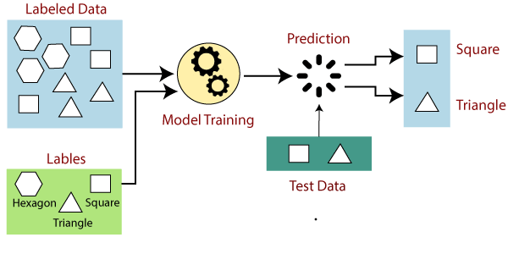
Figure 2.3(a) Supervised Learning
Here's a brief overview of supervised learning:
- Input-Output Mapping: In supervised learning, the algorithm is provided with a dataset containing input variables (features) along with corresponding output labels (targets). The algorithm learns the relationship between the input and output by analyzing the training data.

- Types of Supervised Learning Algorithms:
- Regression: Regression algorithms are used when the output variable is a continuous value. They predict a quantity, such as price, temperature, or sales, based on input features. Linear regression, polynomial regression, and support vector regression are common regression techniques.
- Classification: Classification algorithms are employed when the output variable is a category or label. They classify input data into predefined classes or categories. Examples include logistic regression, decision trees, random forests, support vector machines (SVM), and neural networks.

- Training Process: During the training phase, the algorithm iteratively adjusts its parameters to minimize the difference between predicted outputs and actual outputs in the training data. This process involves optimization techniques like gradient descent, which updates the model's parameters to reduce the prediction error.

- Evaluation and Testing: Once trained, the model is evaluated using a separate dataset called the test set. The performance metrics such as accuracy, precision, recall, F1 score, and confusion matrix are used to assess the model's effectiveness in making predictions on unseen data.

- Applications: Supervised learning finds applications in various fields, including:
- Predictive analytics: Predicting customer churn, stock prices, or housing prices.
- Medical diagnosis: Identifying diseases based on patient symptoms and medical history.
- Image recognition: Classifying images into different categories, such as identifying objects in photographs.
- Natural language processing: Text classification, sentiment analysis, and machine translation.
Supervised learning is a powerful approach for solving a wide range of problems where labeled data is available. It forms the basis for many advanced machine learning techniques and plays a crucial role in real-world applications across different domains.

2. Unsupervised Learning
Unsupervised learning is a type of machine learning that involves training a model on unlabeled data, where the algorithm searches for previously unknown patterns within the data sets. In unsupervised learning, the algorithms are left to discover interesting structures in the data on their own, without any corresponding output variables.
In contrast to supervised learning, unsupervised learning does not rely on labeled data, but instead, it tries to find the patterns directly from the example given. It is particularly useful for data exploration, anomaly detection, and feature learning.
One common unsupervised learning technique is clustering, which involves grouping similar data points together based on their features. For example, in the context of the Iris dataset, the unsupervised algorithm will predict which class the iris belongs to based on the four features of the flower.
Another unsupervised learning technique is dimensionality reduction, which involves reducing the number of features or dimensions in the data while preserving the essential information. This technique is particularly useful for visualizing high-dimensional data and for improving the performance of machine learning models.
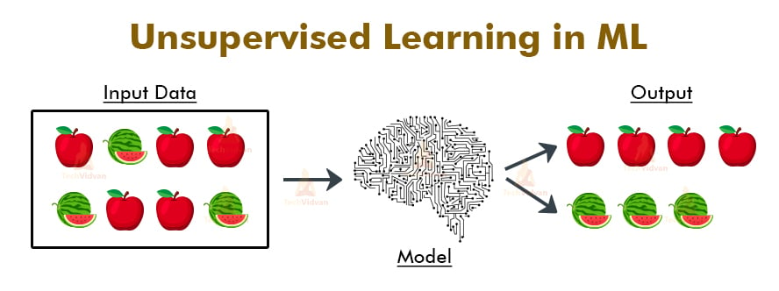
Figure 2.3(b) Unsupervised Learning
Unsupervised learning is a branch of machine learning where the algorithm learns patterns and structures from unlabeled data without explicit supervision. Unlike supervised learning, there are no predefined output labels, and the algorithm must discover the underlying structure of the data on its own. Here's a brief overview of unsupervised learning:
- Clustering:
- Clustering is a common task in unsupervised learning where similar data points are grouped together into clusters.
- The objective is to partition the data into clusters such that data points within the same cluster are more similar to each other than to those in other clusters.
- Popular clustering algorithms include K-means clustering, hierarchical clustering, and Gaussian mixture models (GMM).

- Dimensionality Reduction:
- Dimensionality reduction techniques aim to reduce the number of features or variables in a dataset while preserving its essential information.
- By reducing the dimensionality of the data, it becomes easier to visualize and analyze, and it can also help in improving the performance of machine learning algorithms.
- Principal Component Analysis (PCA) and t-distributed Stochastic Neighbor Embedding (t-SNE) are commonly used dimensionality reduction techniques.

- Anomaly Detection:
- Anomaly detection, also known as outlier detection, involves identifying data points that deviate significantly from the rest of the dataset.
- It is useful for detecting fraudulent activities, unusual patterns in data, or faulty components in systems.
- Anomaly detection algorithms include density-based techniques like Local Outlier Factor (LOF) and isolation forest, as well as distance-based methods like k-nearest neighbors (KNN).

- Association Rule Mining:
- Association rule mining aims to discover interesting relationships or associations between variables in large datasets.
- It is commonly used in market basket analysis to identify patterns in consumer purchasing behavior.
- The Apriori algorithm is a well-known association rule mining technique that identifies frequent itemsets and generates association rules based on support and confidence measures.
Unsupervised learning techniques play a crucial role in exploratory data analysis, pattern recognition, and data preprocessing. They are widely used in various domains, including customer segmentation, anomaly detection, and recommendation systems, among others. Understanding unsupervised learning algorithms is essential for uncovering hidden insights and patterns in unlabeled data.

3. Reinforcement Learning
Reinforcement learning is a type of machine learning that involves an agent learning to make decisions by interacting with an environment. The agent learns through trial and error, receiving rewards or penalties based on its actions. This type of learning is particularly useful for tasks that involve sequential decision making, such as robotics, gaming, and navigation.
In reinforcement learning, the agent learns to maximize the cumulative reward over time. The agent takes actions based on the current state of the environment, and then receives a reward or penalty based on the outcome of the action. The agent uses this feedback to update its knowledge and improve its future actions.
In Python, reinforcement learning can be implemented using libraries such as TensorFlow and Keras. These libraries provide powerful tools for building and training reinforcement learning models.
During the internship program at EduPhoenix Solutions, interns will learn about the fundamentals of reinforcement learning, including the Markov decision process, Q-learning, and policy gradients. They will also have the opportunity to work on real-world projects that involve reinforcement learning, such as building a reinforcement learning model for a self-driving car or a game-playing agent.
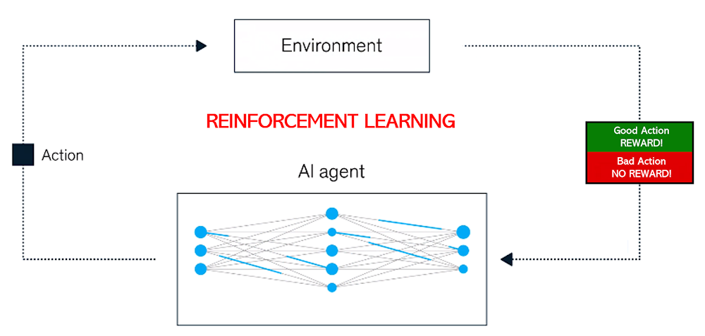
Figure 2.3(c) Reinforcement Learning
Reinforcement learning (RL) is a branch of machine learning where an agent learns to make decisions by interacting with an environment to maximize cumulative rewards. Unlike supervised learning, where the model learns from labeled data, and unsupervised learning, where the model uncovers hidden patterns in unlabeled data, reinforcement learning focuses on learning optimal behaviors through trial and error.
In reinforcement learning, the agent interacts with the environment by taking actions based on its current state. After taking an action, the agent receives feedback from the environment in the form of rewards or penalties, which indicates how good or bad the action was. The goal of the agent is to learn a policy—a mapping from states to actions—that maximizes the cumulative reward over time.
Key components of reinforcement learning include:
- Agent: The entity that interacts with the environment and learns to make decisions. The agent takes actions based on its current state and receives rewards or penalties as feedback.

- Environment: The external system with which the agent interacts. It provides feedback to the agent based on the actions it takes.

- State: A representation of the current situation or context in which the agent finds itself. The agent's actions depend on the state it perceives.

- Action: The choices available to the agent at each state. The agent selects actions based on its policy.

- Reward: Feedback from the environment indicating the desirability of an action taken by the agent. The agent's objective is to maximize the cumulative reward over time.
Reinforcement learning algorithms learn through exploration and exploitation. During exploration, the agent tries different actions to discover which ones lead to higher rewards. Through exploitation, the agent exploits its knowledge to choose actions that are expected to yield high rewards based on past experience.
Popular reinforcement learning algorithms include Q-learning, SARSA, Deep Q-Networks (DQN), and policy gradient methods like Proximal Policy Optimization (PPO) and Trust Region Policy Optimization (TRPO). These algorithms have been successfully applied to various tasks, including game playing, robotics, autonomous vehicle control, and recommendation systems.
Overall, reinforcement learning offers a powerful framework for learning optimal decision-making strategies in dynamic and uncertain environments, making it a valuable tool in machine learning research and application development.

2.4 Data Preprocessing and Feature Engineering
Data preprocessing and feature engineering are essential steps in the machine learning pipeline that contribute to the quality and effectiveness of predictive models. During the Machine Learning Internship at EduPhoenix Solutions, interns gain hands-on experience in these critical tasks, which involve transforming raw data into a format suitable for model training and analysis.

Data Preprocessing:
Data preprocessing involves cleaning and transforming raw data to improve its quality and usability for machine learning tasks. This includes handling missing values, removing outliers, and scaling features to ensure uniformity and stability across the dataset. Through techniques such as imputation, normalization, and standardization, interns learn to prepare data for effective model training and evaluation.

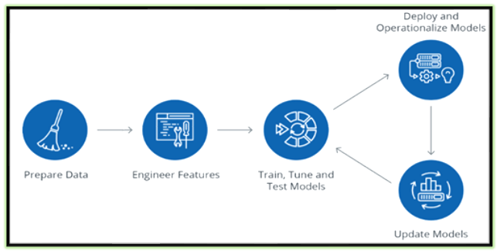
Figure 2.4(a) Data Preprocessing

Feature Engineering:
Feature engineering involves creating new features or transforming existing ones to enhance the predictive power of machine learning models. This includes selecting relevant features, encoding categorical variables, and creating derived features through mathematical transformations or domain-specific knowledge. By identifying informative features and reducing dimensionality, interns optimize model performance and interpretability.
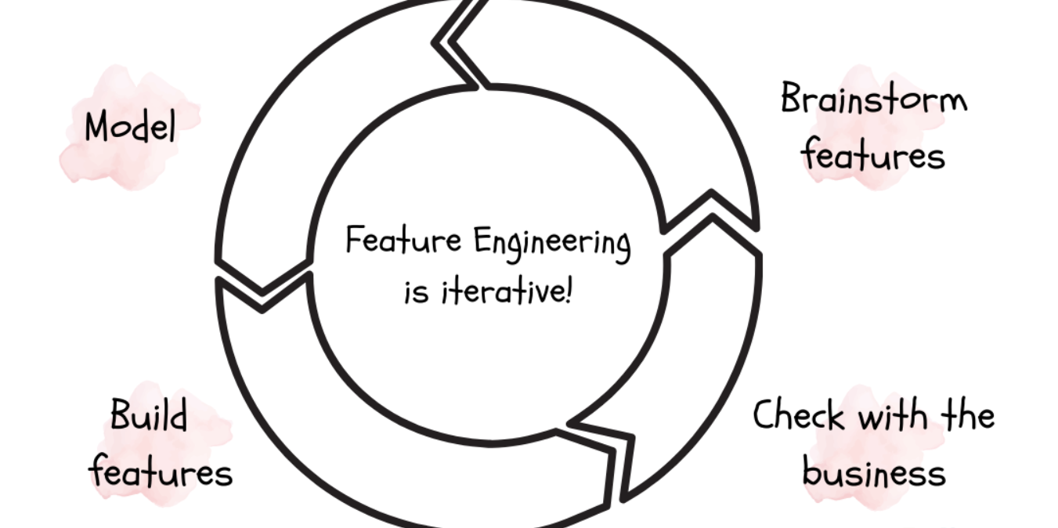
Figure 2.4(b) Feature Engineering

During the Machine Learning Internship at EduPhoenix Solutions, interns work on real-world datasets and projects that require data preprocessing and feature engineering. They gain proficiency in tools and libraries such as pandas, scikit-learn, and TensorFlow, applying techniques such as data cleaning, normalization, one-hot encoding, and feature scaling to prepare data for model training. By mastering these fundamental tasks, interns lay the foundation for building robust and accurate machine learning models that deliver actionable insights and value to stakeholders.
Data preprocessing and feature engineering are integral components of the machine learning workflow, essential for extracting meaningful patterns and relationships from data. Through the Machine Learning Internship at EduPhoenix Solutions, interns develop expertise in these key tasks, equipping them with the skills and knowledge needed to tackle real-world machine learning challenges and drive innovation in the field.

2.5 Model Evaluation and Optimization
Model Evaluation and Optimization in machine learning involves assessing the performance of trained models and refining them for better results. At EduPhoenix Solutions, interns engage in various tasks related to this crucial aspect of machine learning.
- Model Evaluation: Interns learn to evaluate models using metrics like accuracy, precision, recall, F1-score, and area under the ROC curve (AUC-ROC). They understand the significance of choosing appropriate evaluation metrics based on the problem domain and the nature of the data.
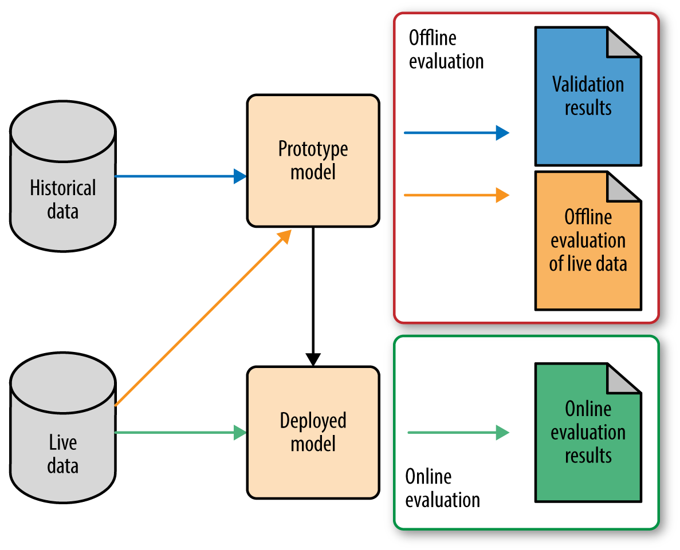
Figure 2.5(a) Model Evaluation
- Cross-Validation: Interns explore techniques like k-fold cross-validation to ensure the robustness of their models. They understand how cross-validation helps in estimating the performance of a model on unseen data and mitigates issues like overfitting.
- Hyperparameter Tuning: EduPhoenix Solutions emphasizes the importance of hyperparameter tuning in optimizing model performance. Interns learn techniques like grid search, random search, and Bayesian optimization to find the best hyperparameters for their models.
- Feature Engineering: Interns are encouraged to experiment with feature engineering techniques to improve model performance. They learn how to select relevant features, handle missing values, and transform variables to make them more suitable for modeling.
- Ensemble Methods: Interns explore ensemble methods such as bagging, boosting, and stacking to further enhance model performance. They understand how combining multiple models can often lead to better results than individual models.
- Performance Visualization: Interns are trained to visualize model performance using techniques like confusion matrices, ROC curves, and precision-recall curves. They learn how visualizations aid in understanding the strengths and weaknesses of models.
- Model Interpretability: EduPhoenix Solutions emphasizes the importance of model interpretability. Interns learn techniques to interpret black-box models and communicate their findings effectively to stakeholders.
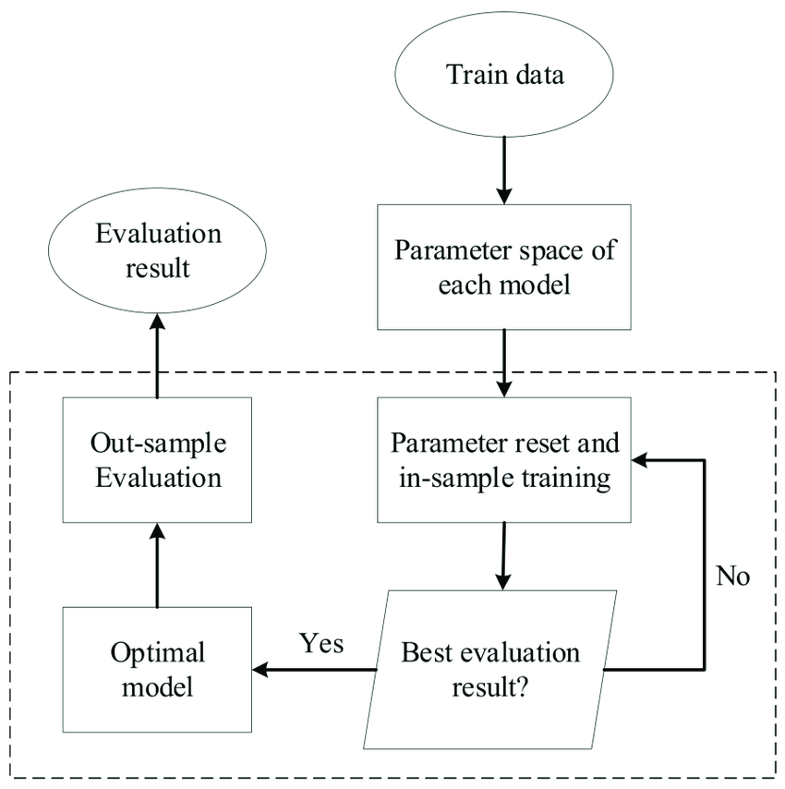
Figure 2.5(b) Model Optimization
By focusing on model evaluation and optimization, interns at EduPhoenix Solutions gain practical experience in building reliable and efficient machine learning models that address real-world challenges effectively.

CHAPTER 3
INTERNSHIP TASK/DAILY-LOGS

CHAPTER 4
PROJECT

CHAPTER 5
CAREER OPPORTUNITIES

Machine Learning offers a wide range of exciting career opportunities for individuals with skills in data analysis, machine learning, and statistics. At EduPhoenix Solutions, interns are exposed to various career paths within the field of Machine Learning and are equipped with the necessary skills and knowledge to pursue these opportunities.
- Machine Learning Engineer: Develop and deploy machine learning models to solve real-world problems, requiring expertise in programming, data preprocessing, model selection, and optimization.

- Data Scientist: Analyze large datasets to extract insights and build predictive models, utilizing statistical analysis, data visualization, and machine learning algorithms to inform decision-making.

- AI Research Scientist: Conduct cutting-edge research in machine learning and artificial intelligence, exploring novel algorithms, developing prototypes, and contributing to advancements in the field.

- Data Engineer: Design and maintain data pipelines to support machine learning systems, specializing in data infrastructure technologies such as Hadoop, Spark, and Kafka for efficient data processing and storage.

- AI Ethics Specialist: Advocate for responsible AI practices, assessing the ethical implications of machine learning algorithms, developing guidelines, and promoting diversity and fairness in AI applications.

- Natural Language Processing (NLP) Engineer: Specialize in developing algorithms and models for understanding and generating human language, applying techniques such as sentiment analysis, text summarization, and language translation.

- Computer Vision Engineer: Focus on designing algorithms and systems for analyzing and interpreting visual data, including tasks such as image classification, object detection, and facial recognition.

- Machine Learning Product Manager: Lead the development and implementation of machine learning-based products and solutions, working closely with cross-functional teams to define product strategy, prioritize features, and drive product innovation.
- Deep Learning Engineer: Specialize in developing and deploying deep neural network models for complex tasks such as image recognition, speech recognition, and natural language understanding, leveraging frameworks like TensorFlow and PyTorch.

- Machine Learning Consultant: Provide expert advice and guidance to organizations seeking to leverage machine learning technologies, offering strategic insights, conducting feasibility studies, and overseeing implementation projects.

- Healthcare Data Analyst: Analyze healthcare data to identify trends, patterns, and insights that inform clinical decision-making, resource allocation, and healthcare policy development.

- Financial Quantitative Analyst: Apply machine learning techniques to financial data for risk assessment, portfolio optimization, and algorithmic trading, contributing to investment strategies and financial decision-making.

- Autonomous Vehicle Engineer: Develop machine learning algorithms and systems for autonomous vehicles, including perception, planning, and control algorithms that enable safe and efficient navigation in real-world environments.

- Machine Learning Research Engineer: Conduct applied research in machine learning, exploring new algorithms, methodologies, and techniques to address challenging problems in various domains such as healthcare, finance, and robotics.

- Cybersecurity Analyst: Utilize machine learning techniques to detect and mitigate security threats, including anomaly detection, malware classification, and network intrusion detection, protecting organizations from cyber attacks and data breaches.

CHAPTER 6
FUTURE TRENDS
The Machine Learning Internship at EduPhoenix Solutions offers opportunities to explore cutting-edge technologies and methodologies in ML. Interns gain exposure to industry best practices and collaborate on projects that address current challenges and future trends.
- Deep Learning Advancements: Deep learning, a subset of ML, is expected to witness significant advancements, particularly in areas such as natural language processing (NLP), computer vision, and speech recognition. Techniques like Transformer models and generative adversarial networks (GANs) are poised to revolutionize various applications.

- Explainable AI (XAI): As AI systems become increasingly complex, there is a growing demand for explainable AI solutions that provide insights into model predictions and decision-making processes. XAI techniques aim to enhance transparency, accountability, and trust in AI systems across industries.

- Federated Learning: Federated learning enables model training across decentralized devices or servers while preserving data privacy. This approach is well-suited for applications in healthcare, finance, and IoT, where sensitive data is distributed across multiple sources.

- AI Ethics and Bias Mitigation: Ethical considerations in AI development are gaining prominence, with efforts focused on mitigating biases, ensuring fairness, and promoting transparency and accountability in algorithmic decision-making. AI ethics frameworks and guidelines are being developed to address these challenges.

- Edge Computing and ML: Edge computing brings computation closer to the data source, enabling real-time inference and decision-making at the edge of the network. Integrating ML models with edge devices and sensors facilitates applications such as smart cities, autonomous vehicles, and industrial IoT.

- AutoML and Model Interpretability: Automated machine learning (AutoML) platforms streamline the process of model development and deployment, making ML more accessible to non-experts. Additionally, emphasis is placed on model interpretability techniques that enhance understanding and trust in ML models.

- Continual Learning and Lifelong Learning: Traditional ML models are often trained on static datasets and may struggle to adapt to evolving data distributions. Continual learning and lifelong learning techniques enable models to learn incrementally over time, improving adaptability and robustness.

- Quantum Machine Learning: Quantum computing holds the promise of exponential speedup for certain ML tasks, such as optimization and pattern recognition. Quantum machine learning algorithms are being explored to harness the power of quantum computers for solving complex problems.

- Meta-Learning: Meta-learning, or learning to learn, involves developing algorithms that can quickly adapt to new tasks and environments by leveraging past experiences. This approach enables more efficient and adaptive machine learning systems.

- Self-Supervised Learning: Self-supervised learning techniques enable models to learn from unlabeled data, leveraging inherent structures and relationships within the data itself. This approach reduces the reliance on labeled data and facilitates learning in data-scarce domains.

- Robustness and Security: With the increasing deployment of machine learning systems in critical applications, ensuring robustness and security against adversarial attacks and data drifts is paramount. Techniques for adversarial robustness, privacy-preserving machine learning, and model fairness are expected to gain prominence.

- Human-Machine Collaboration: Human-machine collaboration involves integrating human expertise and intuition with machine learning algorithms to solve complex problems more effectively. Interactive machine learning techniques enable seamless collaboration between humans and AI systems, leading to enhanced productivity and decision-making.

- Domain-Specific AI: Domain-specific AI solutions tailored to specific industries or applications, such as healthcare, finance, and agriculture, are expected to proliferate. These solutions address unique challenges and requirements within each domain, leading to more impactful and targeted outcomes.

- Neurosymbolic AI: Neurosymbolic AI combines the strengths of neural networks and symbolic reasoning to enable more interpretable and generalizable machine learning models. Integrating symbolic knowledge representation with neural computation enhances model understanding and reasoning capabilities.

- Multi-Modal Learning: Multi-modal learning techniques enable models to process and integrate information from multiple modalities such as text, images, and audio. This approach facilitates richer and more comprehensive understanding of complex data sources, leading to improved performance in various tasks.
- Edge AI and IoT Integration: Edge AI solutions, coupled with the Internet of Things (IoT), enable real-time inference and decision-making at the edge of the network. This integration reduces latency, bandwidth usage, and privacy concerns, making AI more accessible and efficient in edge computing environments.

- Ethical AI Governance: As AI technologies become more pervasive, there is a growing emphasis on ethical AI governance frameworks and regulations. Ethical considerations such as accountability, transparency, and fairness are integrated into AI development processes to ensure responsible and ethical use of AI systems.

- AI-Driven Creativity: AI-driven creativity involves leveraging machine learning algorithms to assist and augment human creativity in fields such as art, music, and design. Generative models, creative AI tools, and collaborative AI platforms empower individuals to explore new creative possibilities and push the boundaries of artistic expression.
These future trends in machine learning reflect ongoing advancements and innovations in the field, shaping the trajectory of AI development and its impact on society and industry.

CHAPTER 7
CONCLUSION

The machine learning internship at EduPhoenix Solutions provided me with a comprehensive and enriching learning experience. Through hands-on projects, mentorship, and exposure to real-world applications, I gained a deep understanding of the various aspects of machine learning and its potential to drive innovation and business transformation.
During the internship, I had the opportunity to work on a diverse range of machine learning tasks, including supervised learning, unsupervised learning, and deep learning. I applied these techniques to solve complex problems in domains such as predictive analytics, computer vision, and natural language processing. The experience of working with cross-functional teams, iterating on solutions, and presenting my findings to stakeholders was invaluable.
Moreover, the internship allowed me to explore the different career paths within the machine learning field, from machine learning engineering and data science to AI research and product management. This exposure broadened my understanding of the industry and helped me identify the areas that align best with my interests and strengths.
Beyond the technical skills, the internship also emphasized the importance of critical thinking, problem-solving, and effective communication – all essential for success in the rapidly evolving field of machine learning. The mentorship and guidance provided by the experienced professionals at EduPhoenix Solutions were instrumental in shaping my professional development and preparing me for the challenges that lie ahead.
As I reflect on my time at EduPhoenix Solutions, I am grateful for the opportunity to have been a part of this dynamic and innovative environment. The knowledge, skills, and practical experience gained during the internship have not only strengthened my technical expertise but also inspired me to continue exploring the boundless possibilities of machine learning. I am excited to apply these learnings and embark on the next chapter of my career, driven by the passion to make a meaningful impact through the power of machine learning.
CHAPTER 8
REFERENCES

1. Alpaydin, E. (2020). Introduction to Machine Learning (4th ed.). The MIT Press.

2. Bishop, C. M. (2006). Pattern Recognition and Machine Learning. Springer.

3. Chollet, F. (2018). Deep Learning with Python. Manning Publications.

4. Cutler, A., Cutler, D. R., & Stevens, J. R. (2012). Random Forests. In C. Zhang & Y. Ma (Eds.), Ensemble Machine Learning (pp. 157–175). Springer.

5. Domingos, P. (2015). The Master Algorithm: How the Quest for the Ultimate Learning Machine Will Remake Our World. Basic Books.

6. Géron, A. (2019). Hands-On Machine Learning with Scikit-Learn, Keras, and TensorFlow (2nd ed.). O'Reilly Media.

7. Goodfellow, I., Bengio, Y., & Courville, A. (2016). Deep Learning. The MIT Press.

8. Hastie, T., Tibshirani, R., & Friedman, J. (2009). The Elements of Statistical Learning: Data Mining, Inference, and Prediction (2nd ed.). Springer.

9. Hyndman, R. J., & Athanasopoulos, G. (2018). Forecasting: Principles and Practice (3rd ed.). OTexts.

10. Kingma, D. P., & Ba, J. (2015). Adam: A Method for Stochastic Optimization. In ICLR.

11. LeCun, Y., Bengio, Y., & Hinton, G. (2015). Deep Learning. Nature, 521(7553), 436–444.

12. Liaw, A., & Wiener, M. (2002). Classification and Regression by RandomForest. R News, 2(3), 18–22.

13. Murphy, K. P. (2012). Machine Learning: A Probabilistic Perspective. The MIT Press.

14. Pedregosa, F., Varoquaux, G., Gramfort, A., Michel, V., Thirion, B., Grisel, O., Blondel, M., Prettenhofer, P., Weiss, R., Dubourg, V., Vanderplas, J., Passos, A., Cournapeau, D., Brucher, M., Perrot, M., & Duchesnay, E. (2011). Scikit-learn: Machine Learning in Python. Journal of Machine Learning Research, 12, 2825–2830.

15. Raschka, S. (2015). Python Machine Learning. Packt Publishing.

16. Rumelhart, D. E., Hinton, G. E., & Williams, R. J. (1986). Learning Representations by Back-Propagating Errors. Nature, 323(6088), 533–536.

17. Russell, S., & Norvig, P. (2020). Artificial Intelligence: A Modern Approach (4th ed.). Pearson.

18. Shalev-Shwartz, S., & Ben-David, S. (2014). Understanding Machine Learning: From Theory to Algorithms. Cambridge University Press.

19. Simonyan, K., & Zisserman, A. (2015). Very Deep Convolutional Networks for Large-Scale Image Recognition. In ICLR.

20. Sutton, R. S., & Barto, A. G. (2018). Reinforcement Learning: An Introduction (2nd ed.). The MIT Press.

21. Tieleman, T., & Hinton, G. (2012). Lecture 6.5—RmsProp: Divide the Gradient by a Running Average of Its Recent Magnitude. COURSERA: Neural Networks for Machine Learning.

22. Vapnik, V. N. (1995). The Nature of Statistical Learning Theory. Springer.

23. Virtanen, P., Gommers, R., Oliphant, T. E., Haberland, M., Reddy, T., Cournapeau, D., Burovski, E., Peterson, P., Weckesser, W., Bright, J., van der Walt, S. J., Brett, M., Wilson, J., Millman, K. J., Mayorov, N., Nelson, A. R. J., Jones, E., Kern, R., Larson, E., ... SciPy 1.0 Contributors. (2020). SciPy 1.0: Fundamental Algorithms for Scientific Computing in Python. Nature Methods, 17(3), 261–272.

24. Werbos, P. J. (1990). Backpropagation Through Time: What It Does and How to Do It. Proceedings of the IEEE, 78(10), 1550–1560.

25. Wolpert, D. H. (1996). The Lack of A Priori Distinctions Between Learning Algorithms. Neural Computation, 8(7), 1341–1390.

